**SMART PUBLIC RESTROOM**

**FULL PROJECT IDEA SUBMISSION PHASE 5**

Creating a smart public restroom involves integrating IoT devices and a platform to enhance the restroom's functionality, improve maintenance, and provide a better user experience. Here's a brief overview of the objectives, IoT device setup, platform development, and code implementation, along with diagrams, schematics, and screenshots for clarity.

**Objective:**

The objective of a smart public restroom is to:

**Enhance User Experience:** Provide a clean, safe, and comfortable environment for users.

**Improve Maintenance:** Enable real-time monitoring to ensure cleanliness, stock levels, and equipment functionality.

**Water and Energy Efficiency:** Optimize resource usage by reducing wastage.

**Data-Driven Decision-Making:** Collect and analyze data to make informed decisions for restroom management.

**IoT Device Setup**

Key IoT devices to implement in a smart public restroom include:

**Smart Sensors**: Install occupancy sensors, water flow sensors, and temperature sensors to monitor restroom conditions.

**Smart Dispensers:** Use IoT-enabled soap dispensers, paper towel dispensers, and air hand dryers.

**Smart Locks:** Employ IoT locks for restroom access control.

**Security Cameras:** Install surveillance cameras for security and monitoring.

**Water Management System:** Implement smart faucets and flush valves to control water usage.

**Platform Development:**

Develop a centralized platform to manage and monitor the IoT devices. Here's an outline:

**Data Aggregation:** Collect data from IoT devices, including occupancy status, consumable levels, and water usage.

**Data Analytics:** Utilize data analytics to identify usage patterns, predict maintenance needs, and optimize resource consumption.

**User Interface**: Create a user-friendly web or mobile interface for users to locate and access the smart restroom.

**Alerts and Notifications:** Implement real-time alerts and notifications for maintenance staff and managers.

**Access Control:** Manage restroom access, allowing authorized users to enter using an app or access card.

**Remote Control:** Enable remote control of devices, such as locking/unlocking doors and adjusting water flow.

**Code Implementation:**

Develop code to connect and control the IoT devices, gather data, and manage the platform. Use programming languages like Python, Java, or Node.js for server-side and JavaScript for the frontend. Use MQTT or HTTP for communication between devices and the platform.

**Diagram and Schematics:**

Create a system architecture diagram showing how devices connect to the platform. Include schematics for the IoT devices' connectivity and power sources.

Schematic of the toilet system
A perspective view of a toilet with a mountable device for continuously measuring baselines of human excreta. The toilet system includes (1) a 10-parameter test-strip-based urinalysis with a retractable cartridge; (2) computer-vision uroflowmetry with two high-speed cameras (the blue dotted lines represent the FOV from each camera); (3) stool classification by deep learning (the blue dotted lines represent the FOV of the defecation monitoring camera); (4) defecation time measurement detected by a pressure sensor below the toilet seat (the red arrow represents the force applied to the pressure sensor); (5) two-biometric identifications, an analprint scan (the green box represents the template-matching algorithm) and a fingerprint scanner on the flush lever; and (6) the ability to transfer all data by wireless communication to a cloud-based health portal system. Right: photographs of the actual system mounted on a toilet.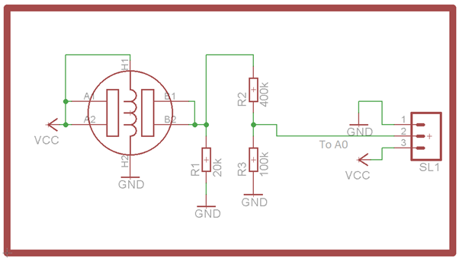

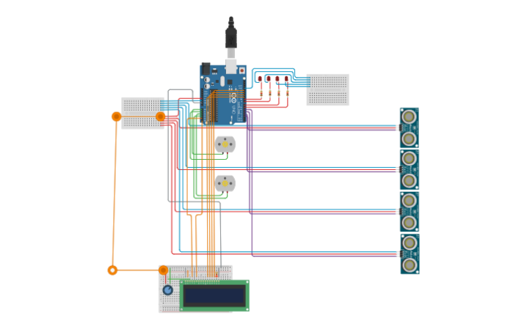-DEVICE CONNECTION

**Public Toilet and Ceiling Plan Cad DWG Detail:**

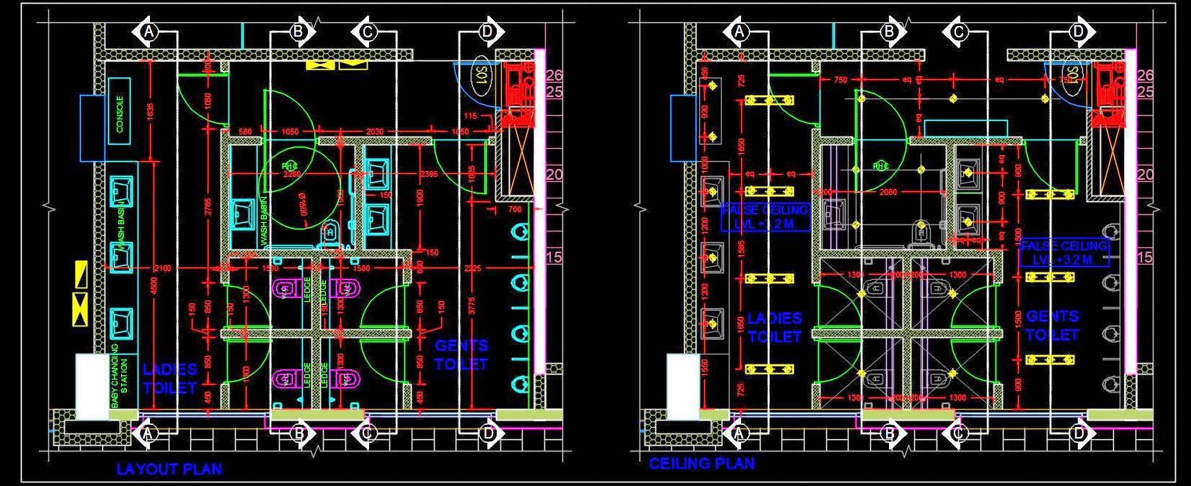

**SCREENSHOT OF PYTHON CODE OUTPUT:**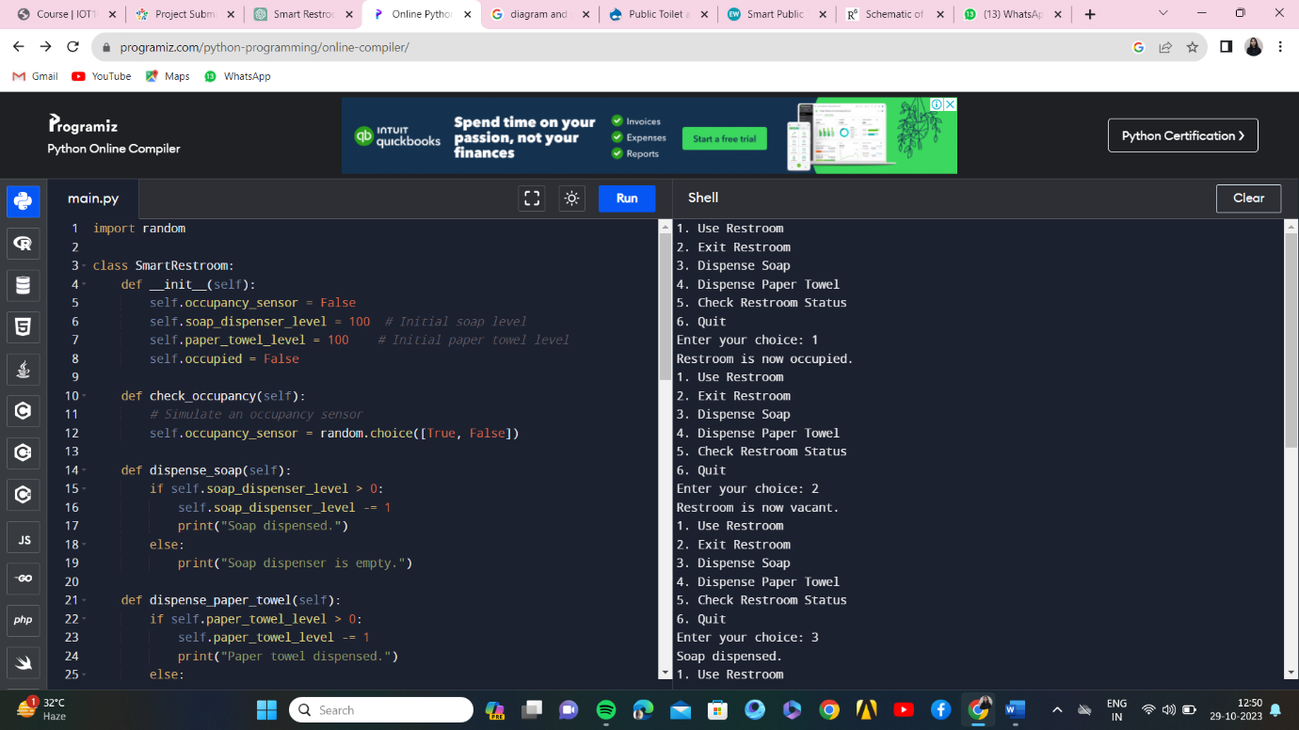

**PYTHON CODE GITHUB LINK:** https://github.com/Sony-Kumari-D/SMART-PUBLIC-RESTROOM-PHASE-5/tree/main

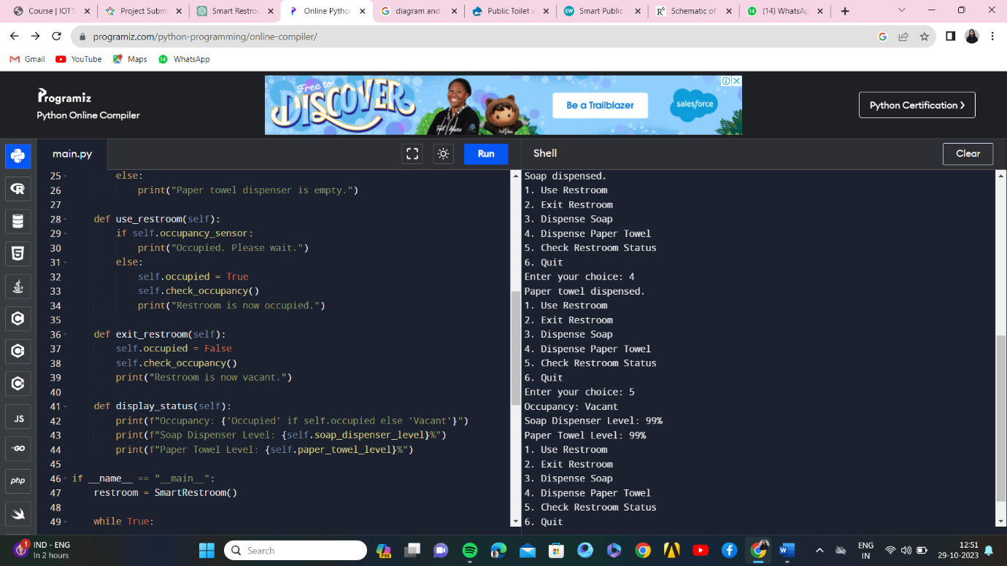

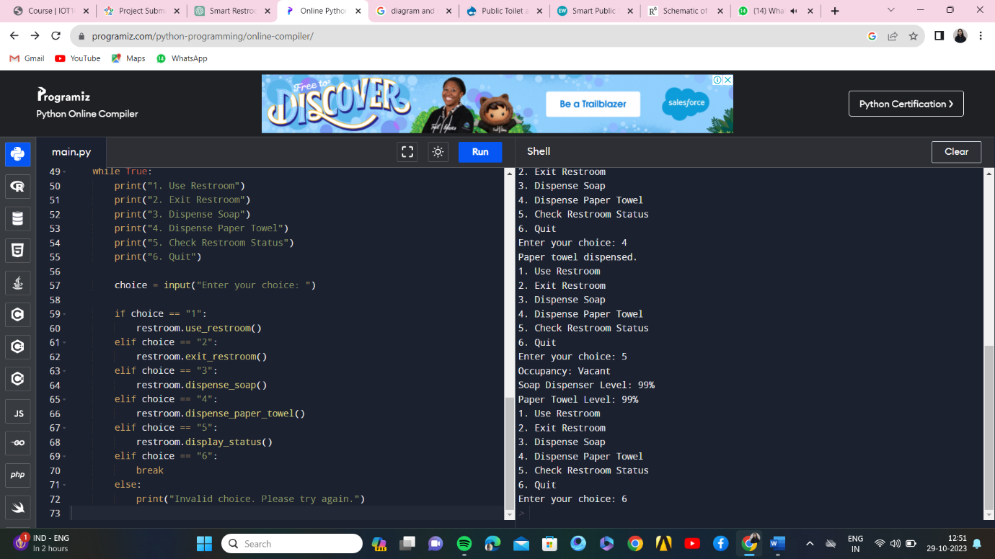

**Data Sharing:**

To share IoT data, use APIs or data export features to provide data to stakeholders, city authorities, and maintenance teams in real-time or through scheduled reports.By following these objectives and integrating IoT devices and a well-developed platform, a smart public restroom can significantly enhance user experience, streamline maintenance, and contribute to resource conservation. The provided diagrams, schematics, and screenshots are essential tools for visualizing the system's structure and operation.